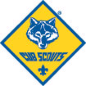
Cub Scout Pack 731
North Reading, MA 01864
http://pack731.tripod.com/

Cub Scout Uniform

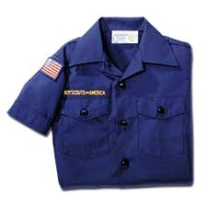
Council Shoulder Patch - 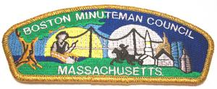
Boston Minuteman Council

Unit Numerals 

Den #
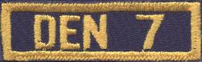
Example only – buy the # assigned to YOUR den

Neckerchief Slide:
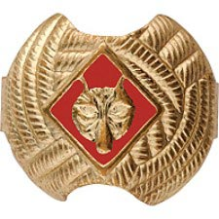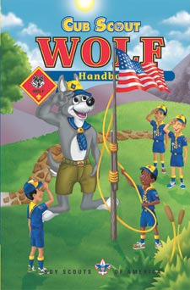

Optional:
- Hat
- Shorts/pants (most don’t get)
- belt

